

**Tunku Abdul Rahman University College**

**Diploma in Information System Engineering**

**AACS2204**

**Object-Oriented Programming Techniques**

**Assignment**

|  |  |  |
| --- | --- | --- |
| **Programme** | **:** | **DIA2** |
| **Tutorial Group** | **:** | **G4** |
| **Date Submitted to Tutor** | **:** |  |

**Team Members:**

|  |  |  |  |  |
| --- | --- | --- | --- | --- |
| **No** | **Student Name** | **Student ID** | **Contribution (%)** | **Signature** |
| **1.** | **LIM SAI KEAT** | **18WMD04304** |  |  |
| **2.** | **ALAN LAU ZI HONG** | **18WMD04439** |  |  |
| **Total** | | | **100** | **-** |

|  |  |  |
| --- | --- | --- |
| No. | Team Member | Task(s) Allocated |
| 1. | LIM SAI KEAT |  |
| 2. | ALAN LAU ZI HONG |  |

**Declaration**

We confirm that we have read and shall comply with all the terms and conditions of TAR University College’s plagiarism policy.

We declare that this assignment is free from all forms of plagiarism and for all intents and purposes is my own properly derived work.

|  |  |  |  |
| --- | --- | --- | --- |
| Signature | : |  |  |
| Name | : | **LIM SAI KEAT** | **ALAN LAU ZI HONG** |
| Date | : |  |  |

Contents

**UML Class Diagram** 4

**Assignment’s idea** 6

**Description of team’s assignment idea.** 6

**Sample screen shots and reports/listings.** 7

**1. Login and Register** 7

1.1 Customer login 7

1.2 Customer sign-up interface 8

1.3 Customer main-menu interface 9

1.4 Customer online ordering interface 10

**2. Point of sale main module – POS System (Staff Module)** 11

2.1 Staff or Manager login 11

2.2 Staff menu 11

2.3 Point of Sales Main Function 12

2.4 Customer Manager 14

**3. Order Manager** 15

**4. Point of sale sub module – POS management system (Manager module)** 16

4.1 Staff and Manager login 16

4.2 Manager menu 17

4.3 Point of sales main function, Customer Manager and Order Manager 18

4.4 Staff Profile Manager 18

4.5 Transaction Manager 19

4.6 Product Manager 20

4.7 View Report Analysis 21

4.8 Insert structured query language command 22

**Appendixes** 23

POS module 23

Customer manager module 23

Staff manager module 24

Payment module 24

Order module 25

Product module 25

Report module 26

Online ordering module 26

# **UML Class Diagram**

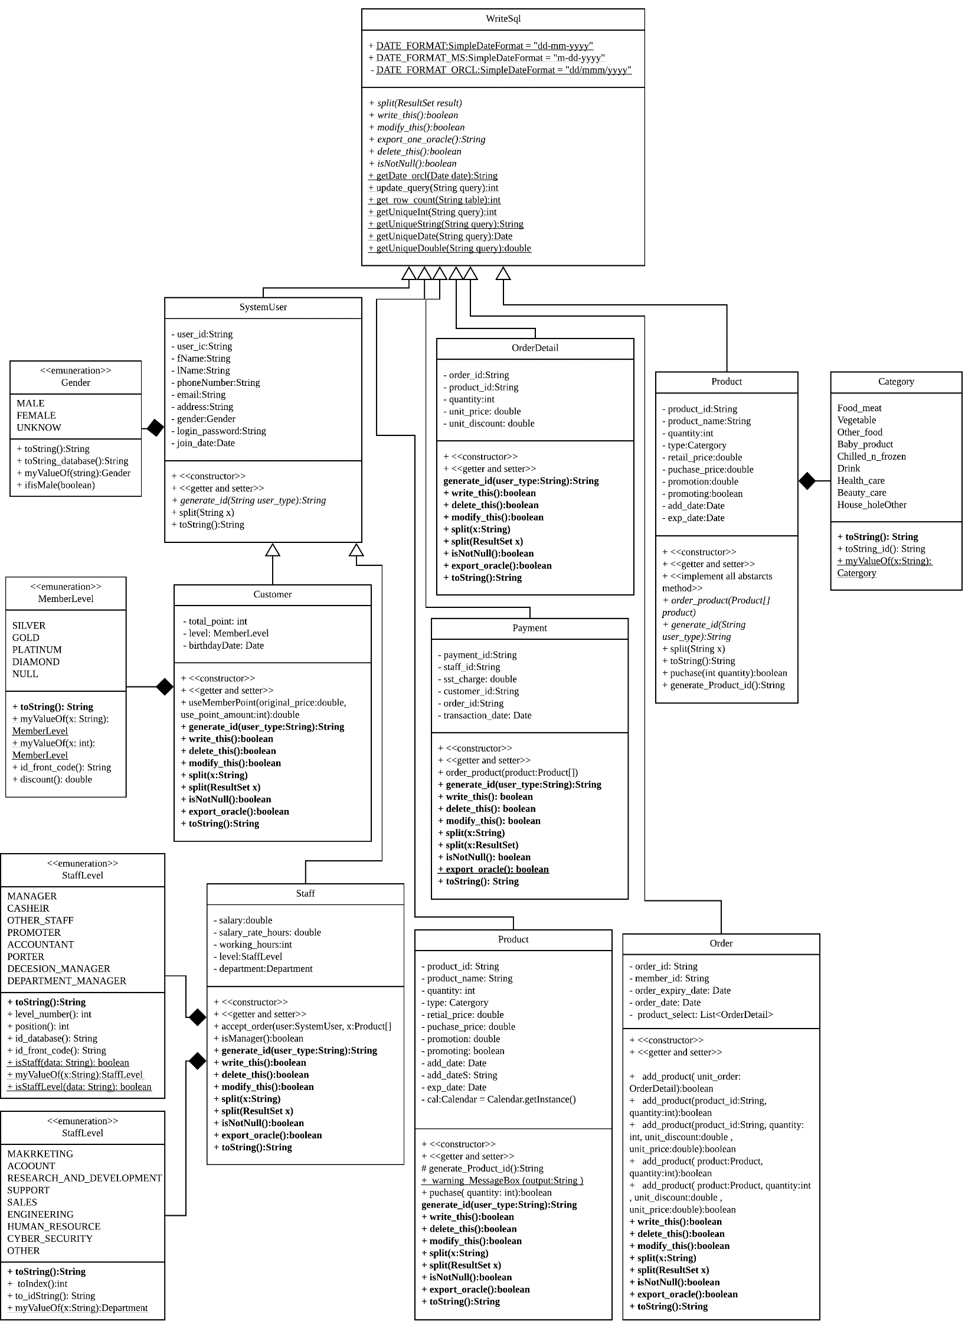

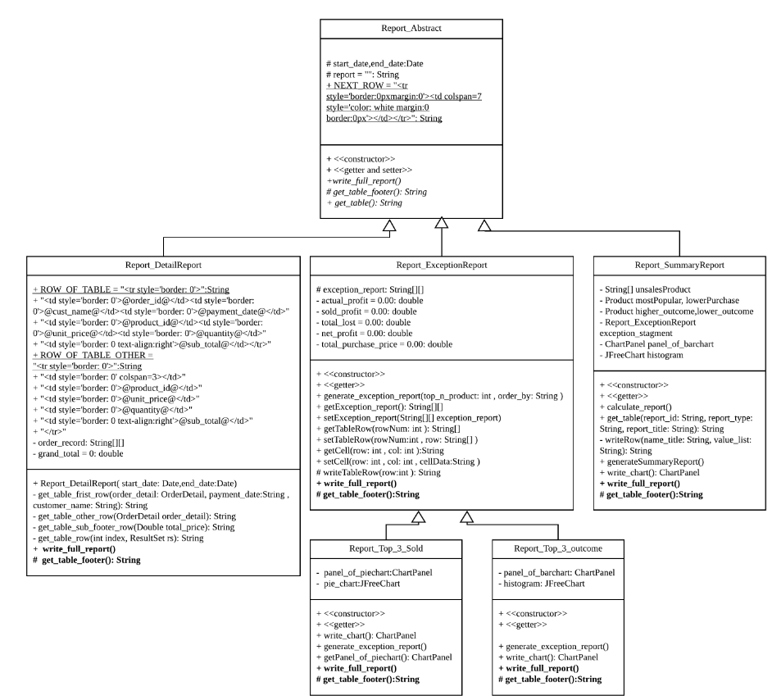

# **Assignment’s idea**

## **Description of team’s assignment idea.**

Our POS System is created on the basis of real POS System in AEON Retailer stores. The features and functions might be different from the actual system but we try to create the similar system with user-friendly characteristics. Our POS System consists of certain important elements which includes Products, Customers, Staff, Order, Payment and submodules on these.

All the modules, classes and functions are actually interrelated as to keep the system become more dynamic and flexible. For example, the customer orders items through this POS System, the item lists will be recorded under this customer’s particular ID. By searching for this customer ID, we can actually get the information of the customer like the customer’s address, email, phone number and so on.

Here’s some tips for you to have a better understanding towards the system. Firstly, this system consists of 8 modules which are as following:

1. POS module [Figure 1]

1.1 Transaction

1.2 Print receipt

1.3 Purchase products

1.4 Add payment

2. Customer manager module [Figure 2]

2.1 Add customer records

2.2 Modify customer records

2.3 Delete customer records

3. Staff manager module [Figure 3]

3.1 Add staff records

3.2 Modify staff records

3.3 Delete staff records

4. Payment module [Figure 4]

4.1 Modify payment details

4.2 Delete payment details

5. Order module [Figure 5]

5.1 Modify order details

5.2 Delete order details

6. Product module [Figure 6]

6.1 Add product details

6.2 Modify product details

6.3 Delete product details

7. Report module [Figure 7]

7.1 Generate Detailed Reports

7.2 Generate Exception Reports

7.3 Generate Summary Reports

8. Online ordering modules [Figure 8]

8.1 Online Order

## **Sample screen shots and reports/listings.**

### **1. Login and Register**

#### 1.1 Customer login

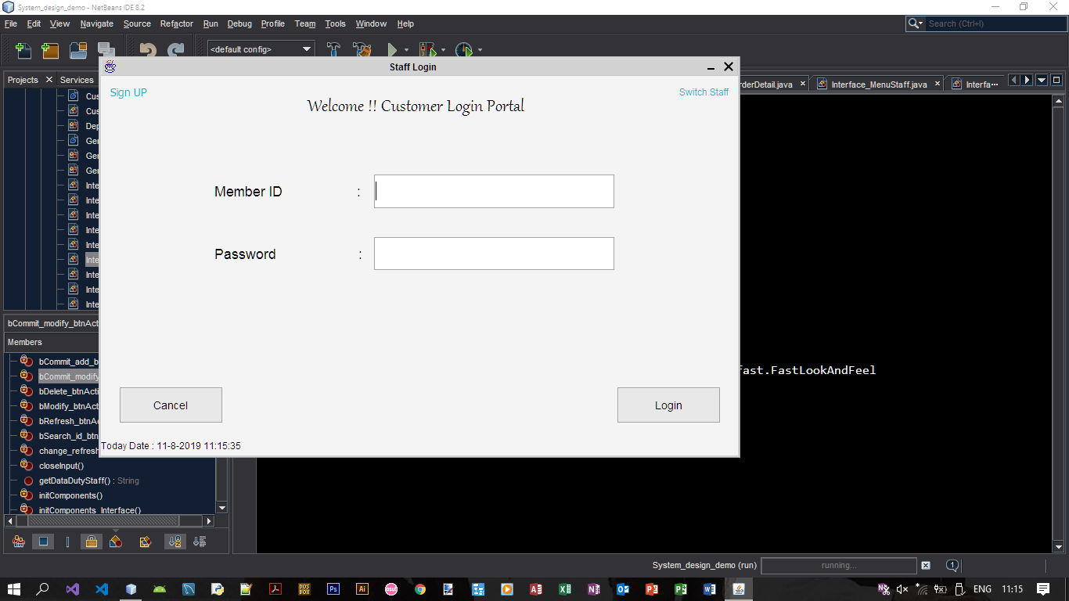

1.1.2

1.1.3

1.1.1

* + 1. Customer sign-up
       1. Click Allow new customer to sign up for the customer not yet register as a member.
       2. Switch to **part 1.2** Customer sign-up interface.
    2. Customer login
       1. Customer allow to login where click the login button system will verify the customer id and password user was key-in.
       2. Password case correct: Display OK button and let user switch to **part 1.3** Customer main-menu interface.
       3. Password case wrong: Error message will stage screen will flip to red – pink color. After wrong more than 3 time will auto close the system.
       4. Login demo – Customer id: ‘NU1104’, Password: ‘Aa73218324’
    3. Switch staff

Once user click will switch o staff login portal **part 2.1** staff login.

#### 1.2 Customer sign-up interface

1.2.6

1.2.5

1.2.4

1.2.3

1.2.2

1.2.1

* 1. 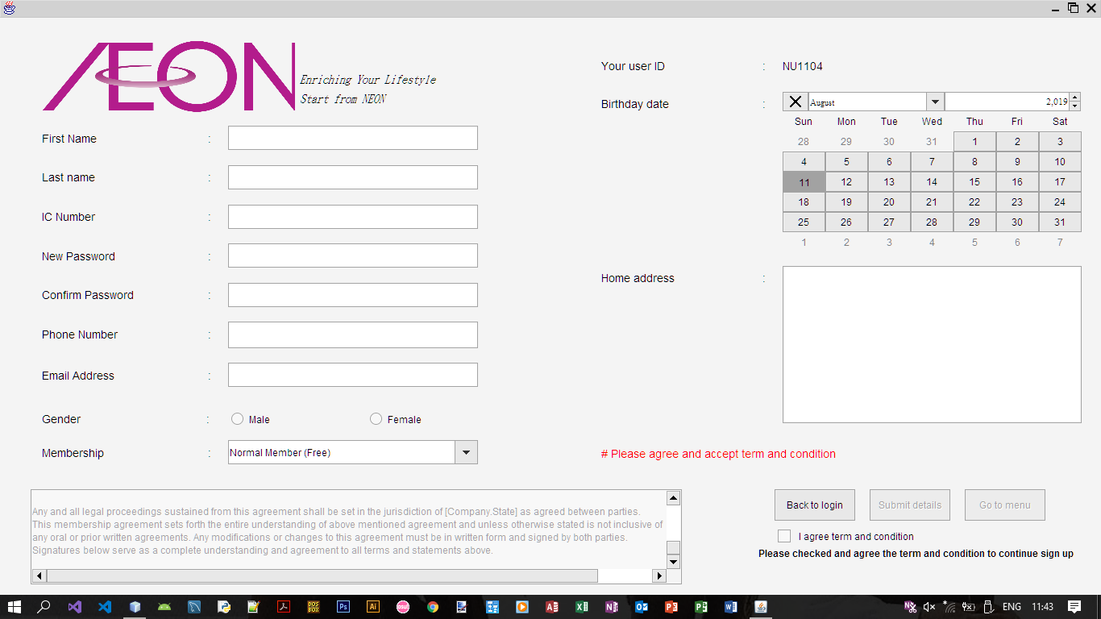
     1. Error message
        1. label all the error message will be display in this label.
     2. Back to login page button
        1. back to previous page **Part 1.1** Customer login.
     3. Submit button
        1. customer cannot click while not yet accept and agree term and condition of Neon company.
        2. After submit validation will be checked by the system if not correct format or not fill in error message will display at **Part 1.2.1**.
     4. Go to menu button
        1. Switch to customer menu page directly.
        2. it will only be able to click after sign-up successful.
     5. Customer detail request – part 1
        1. Display customer id, birthday date selector and Address input field
     6. Customer detail request – part 2

Accept first name, last name, identity card number, new account password, phone number, email address, gender and membership choice

#### 1.3 Customer main-menu interface

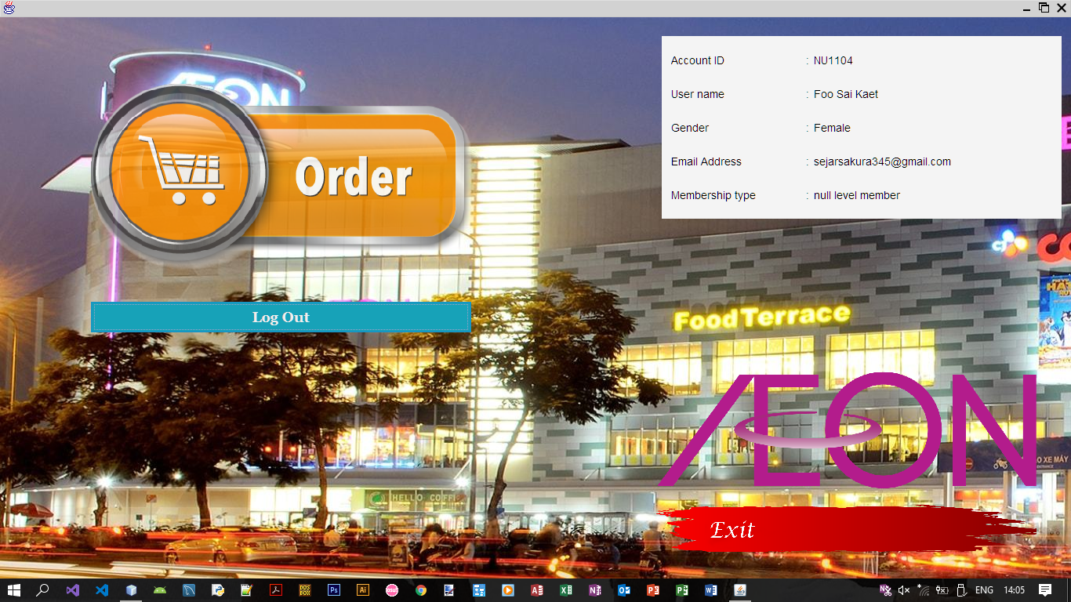

1.3.4

1.3.3

1.3.2

1.3.1

* + 1. Order button
       1. Switch to order page of the system allow user to having online ordering and the order will save as new record
       2. The payment status will default set as not yet paid, they can pay trough online or in outlet to duty staff. Staff will update their payment status and will send the outlet unable product direct to customer home by using customer address.
    2. Logout button
       1. Logout will switch the interface to customer login shown as **part 1.1** and allow the other customer login.
    3. My status pane
       1. The plan that display the customer detail such as name, user id, email address and member level.
    4. Exit button

Once customer click the exit button system will alert ensure customer need to logout or not.   
Yes option – logout without sign-up  
No option – logout with sign  
Cancel option – Don’t logout

#### 1.4 Customer online ordering interface

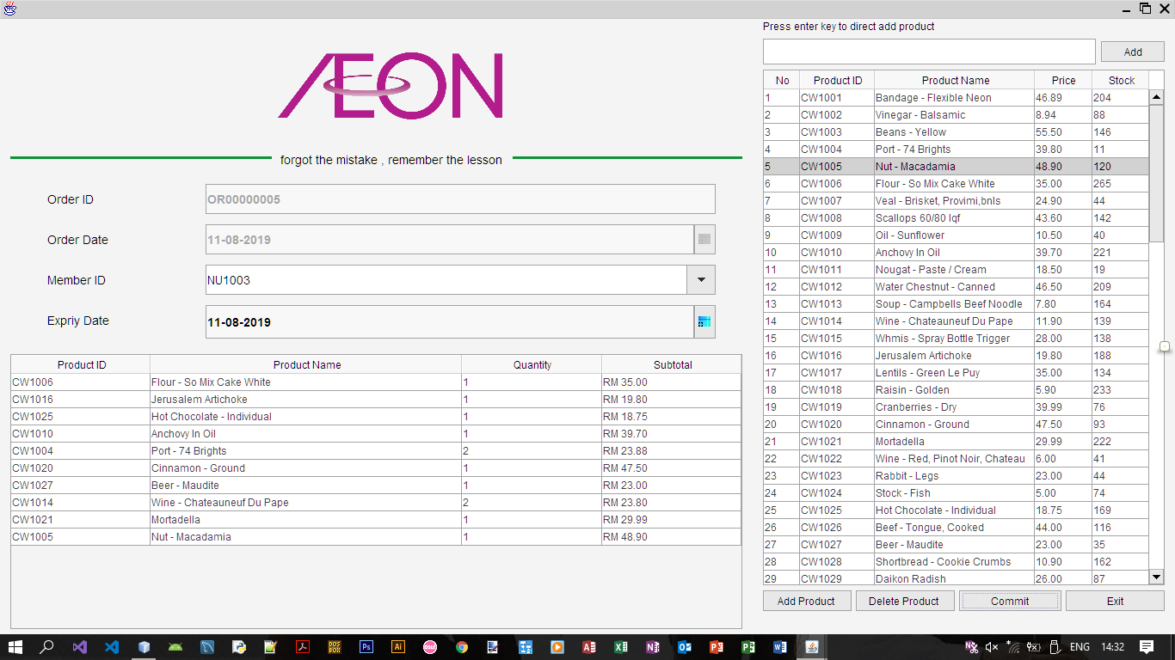

* + 1. Product item list - table
       1. User can choose the product they can double click to submit they result and will default set quantity at one as a selected product.
    2. Selected product list – table
       1. All the selected product will list down at this table user able to direct modify the quantity in the table and will be direct change.
    3. Expiry date selector
       1. User able to select expiry date as their payment deadline.
    4. Product search box
       1. User can enter the product id and name that user want to search the suggestion result will display as above.
    5. Add – button
       1. Add the product inside the search box to selected detail.
    6. Add product – button
       1. Add the product selected in product table **1.4.1** to selected product list **1.4.2**.
    7. Delete product – button
       1. Delete the product from selected table at **1.4.2**.
    8. Commit – button
       1. Submit the order result to database.
    9. Exit – button

Exit the back to customer main menu page shown as **part 1.3**.

### **2. Point of sale main module – POS System (Staff Module)**

Staff is only allow to manipulate the part of system data such as order and dairy transaction and check about the order.

#### 2.1 Staff or Manager login

2.1.1 Same as manager login the detail part refer to **Part 3.1**.

#### 2.2 Staff menu

* + 1. POS main function
       1. Switch to Point Of Sales Menu that can add payment and done the payment.
    2. Customer manager
       1. Switch to the interface that can manipulate customer data to help them solve their problem.
    3. Order manager
       1. Switch to the Order Page that can help customer to correct the order data such as external order or delete order staff and manager not able to having order by using staff account they can sign up a new customer account to having the online ordering.
    4. Logout
       1. Once use click the logout button system will straight away to logout and switch to login interface that allow other user login or staff as well.
    5. Exit
       1. Once user click on the exit button system will double confirm to user that ensure you want to exit without logout or exit with logout or cancel exit.

#### Point of Sales Main Function

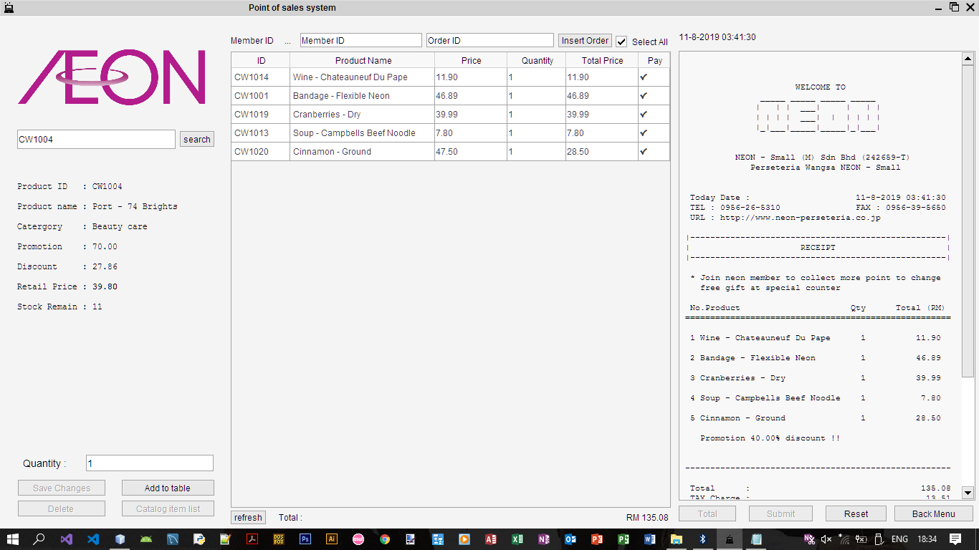

2.2.1 Member id – text field

* + - 1. Staff or manager can help customer fill up member id or not fill up, optional before payment.
    1. Order id – text field
       1. Staff or manager able to insert order id from customer who done online order but not yet pay to done the payment.
    2. Product id – text field
       1. Staff can search the product by entering the product id from user.
    3. Quantity – text field
       1. Where user selected the table row and able to edit the quantity. Till user click the save change button to update the changes
    4. Insert order – button
       1. When user entered the order id to order id text field and click this button will submit the data.
    5. Search – button
       1. Click to submit the search text field.
    6. Save change – button
       1. Click to save change of the edited quantity.
    7. Delete – button
       1. Delete the need delete data at the product table.
    8. Add to table – button
       1. After searching the product when product is valid the add button will be enabled to click to add the product to the table
    9. Catalog item list – button
       1. After click will show this window and allow user choose the product from catalog shown as below.

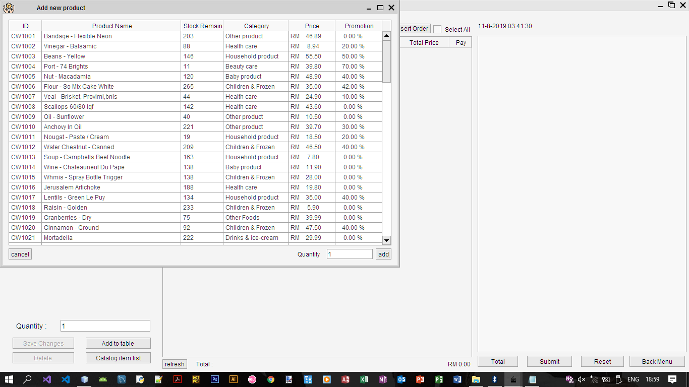

* + 1. Refresh – button
       1. Sometime the product after added might not display click to refresh the buffer and the stored memory
    2. Total – button
       1. Calculate the total and let user view the total use able to adjust before click the submit button
    3. Submit – button
       1. Calculate the total save the updated data to database and generate the receipt and display to user.
       2. After user click the button user not able to edit and adjust the table and other button accept reset button.
       3. Once user click the reset button only can continue to the following payment
    4. Reset – button
       1. Clear all the receipt text and table product list from previous transaction
    5. Back menu – button
       1. Go back to menu, dispose this window. If transaction done halfway will alert user make sure want to exit or not before complete the transaction
    6. Select all – check box
       1. User need to select the product before payment make sure user want to buy. Click this button allow user to select all.
    7. Receipt – text area
       1. The receipt will print to this not editable text area.

#### 2.4 Customer Manager

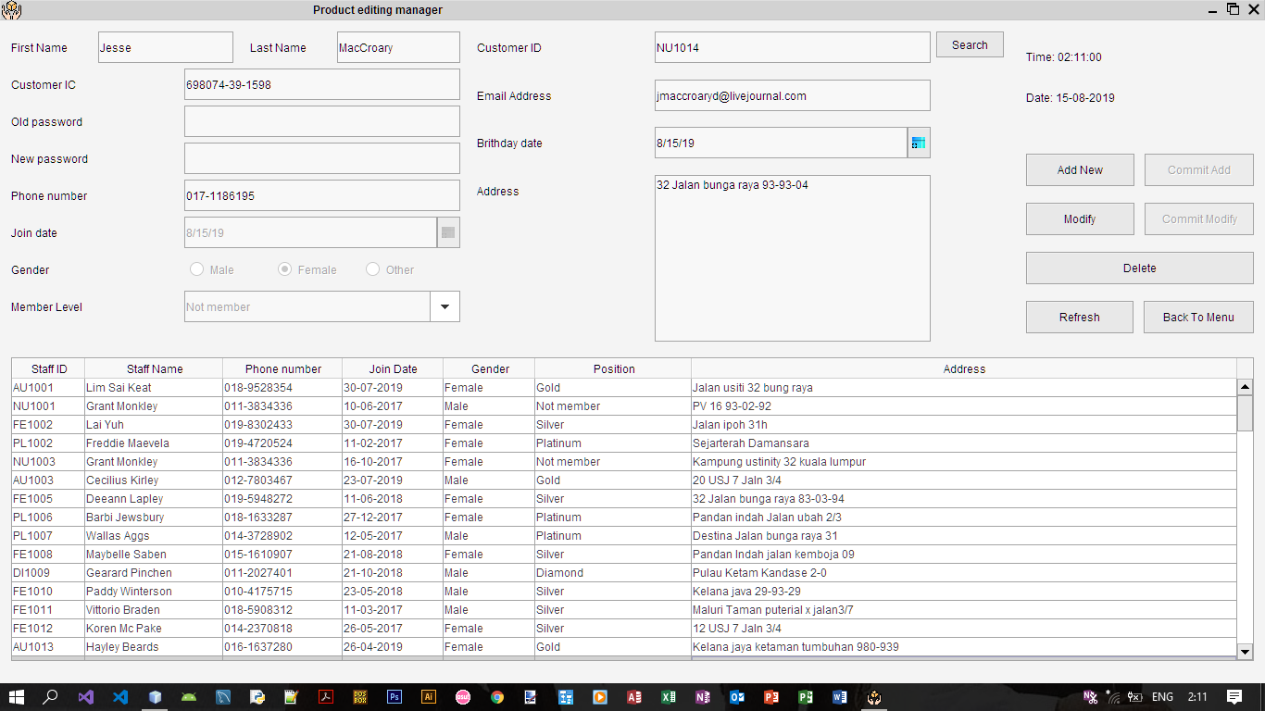

* 1. Customer manager
     1. Input -field
        1. First name – text field
        2. Last name – text field
        3. Customer IC – text field
        4. Old password – password field
        5. New password – password field
        6. Phone number – text field
        7. Join date – date chooser
        8. Gender – check box
        9. Member level – combo box
        10. Customer id – text field
        11. Email address – text field
        12. Birthday date – date chooser
        13. Address – text area

### **3. Order Manager**

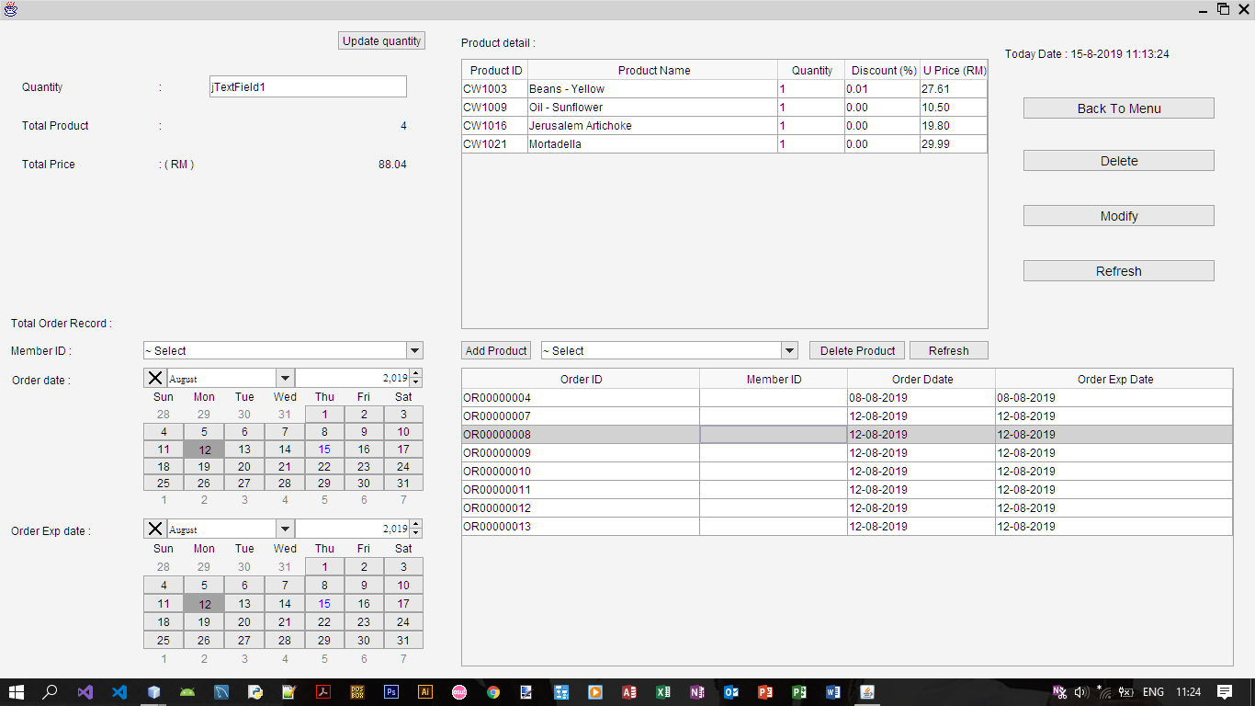

* 1. Order manager in this system is only allow staff to modify or delete the record of the order base on the data shown at the table below shown as diagram above.
  2. The table shown at top pat is the order detail to allow staff to refer to the order detail with each particular order once only the user press to or select the table below only the top part table that is order detail will be shown data.

.

### **4. Point of sale sub module – POS management system (Manager module)**

#### Staff and Manager login

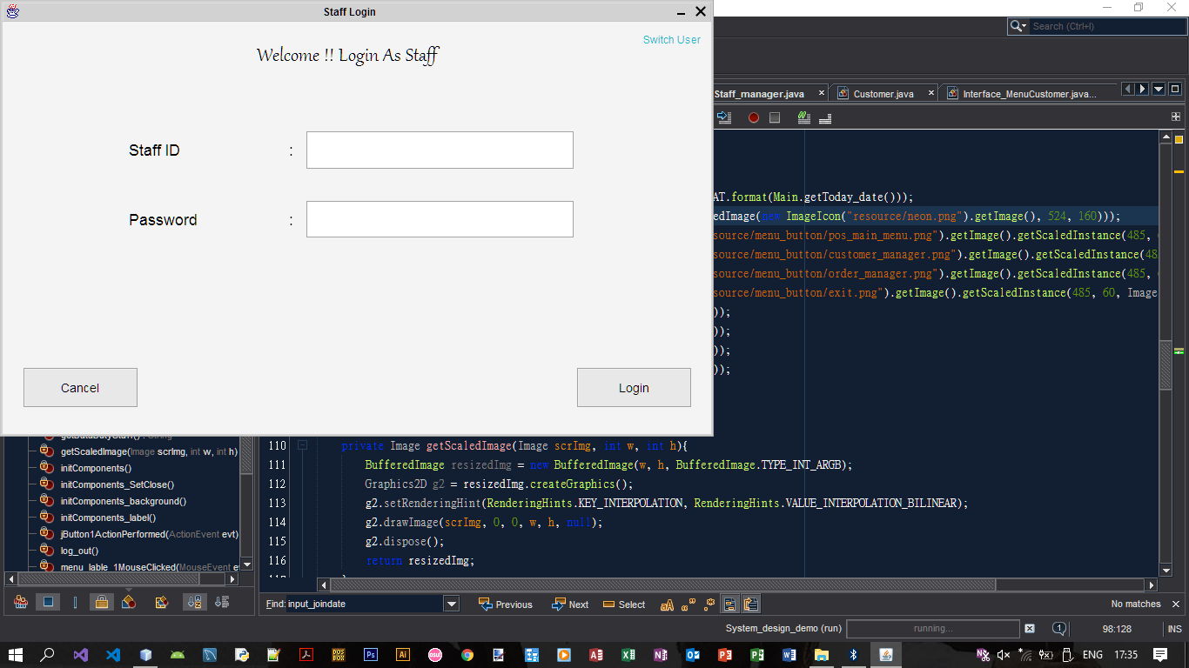

4.1.1Switch user

4.1.1.1Switch to customer login portal page.

* + 1. Cancel – button
       1. Exit and quit the system, cancel login.
    2. Login – button
       1. Validate and login to the system. If successful will switch to staff or manager menu. If login with manager id will switch to manager menu else go to normal staff menu. Unauthorized user id or wrong password will be rejected by the system. Enter wrongly more than 3 time software will be close.
    3. OK – button
       1. After user had enter the correct user ID and the particular password user able to view the ok button, after clicked allow staff or manager to open their main menu.

#### 4.2 Manager menu

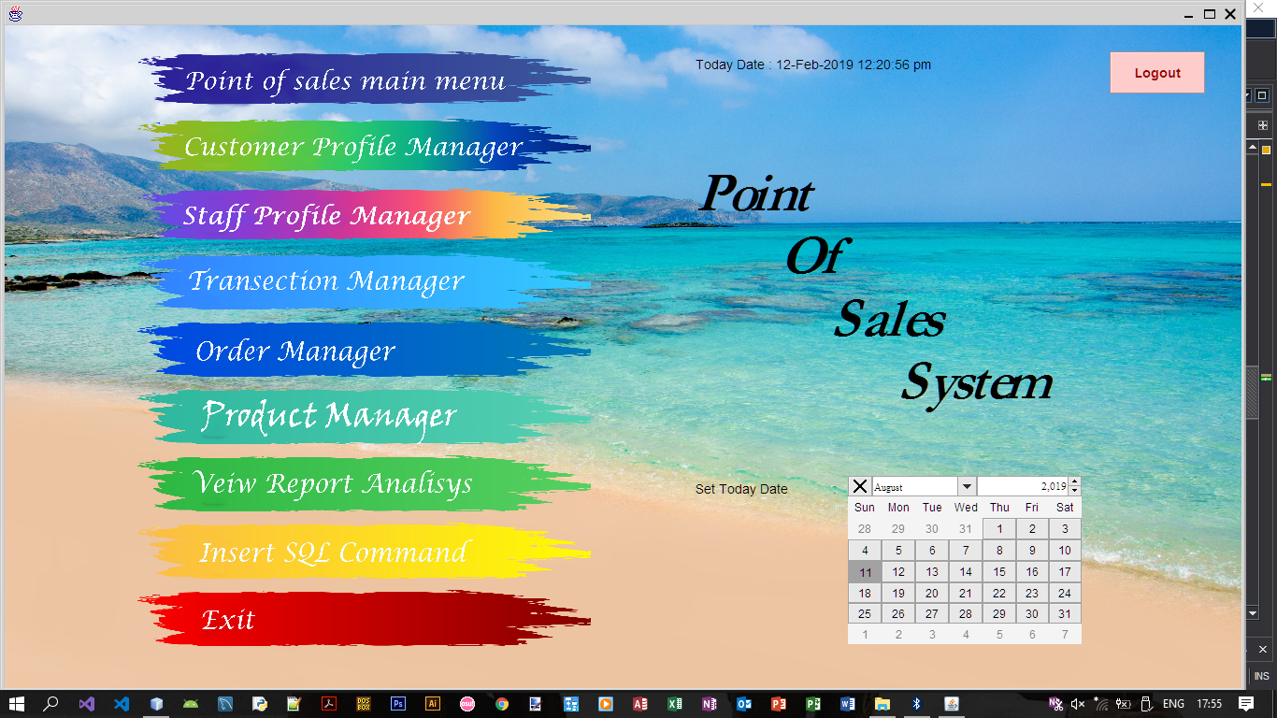

4.2.1 Switch interface button   
 - Switch to the particular interface and dispose this window

4.2.1.1. Point of sales menu – button

4.2.1.2. Customer profile manager – button

* + - 1. Staff profile manager – button

4.2.1.4. Transaction manager – button

4.2.1.5. Order manager – button

4.2.1.6. Product manager – button

4.2.1.7. View report analysis – button

4.2.1.8. Insert SQL command – button

* + 1. Today date selector

4.2.2.1 Manager able to adjust the system date, they only need to click trough the selector than will be able to change. Staff might go to the label above mark as today date above to check to the date.

* + 1. Logout

4.2.3.1 Manager or staff user able to logout and dispose the manager menu and go to the staff login page.

* + 1. Exit

4.2.4.1. The exit button will direct quit the system. System will alert user make sure user want to quit, logout or cancel   
Yes option – logout without sign-up  
No option – logout with sign  
Cancel option – Don’t logout

#### 4.3 Point of sales main function, Customer Manager and Order Manager

* + 1. This part is listed shown as above
    2. Point of sales main function refer to **Part 2.3**.
    3. Customer Manager refer to **Part 2.4**.
    4. Order manager refer to **Part 2.5**.

#### 4.4 Staff Profile Manager

* 1. Staff profile manager

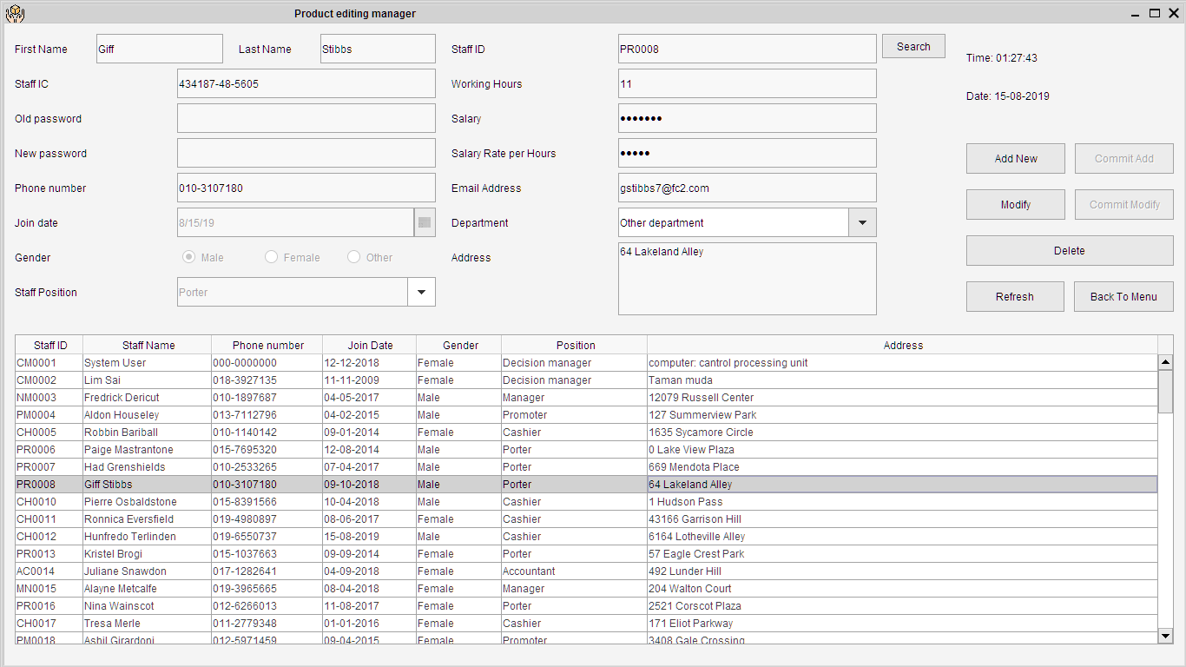

* + 1. This module that have many layer of validation that ensure the staff position lower or same with you is not allow to modify and delete. The meaningful error message will alert when staff or manger try to edit the data.
    2. In this system has many position of staff such as cashier, accountant, manager, department manager and decision manager.
       1. In the program decision manager can edit department manager data but department manager cannot change decision manger data.
    3. Commit add button cannot be click until user click add new.
    4. User must modify before commit modify, User cannot modify or delete when no row is selected.
    5. If user do want to use the table provide below to modify or delete. Staff can using search button show as above click it to enable to search id and after finish enter click back the same button with changed to find to find out he staff if invalid Id entered system will not enable user to modify, delete and meaningful error message will provided.

#### 4.5 Transaction Manager

* 1. Transaction manager

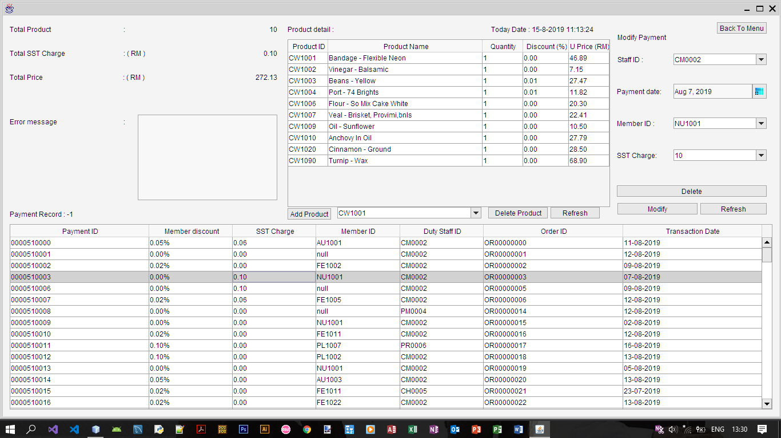

* + 1. X

#### 4.6 Product Manager

* 1. Product manager

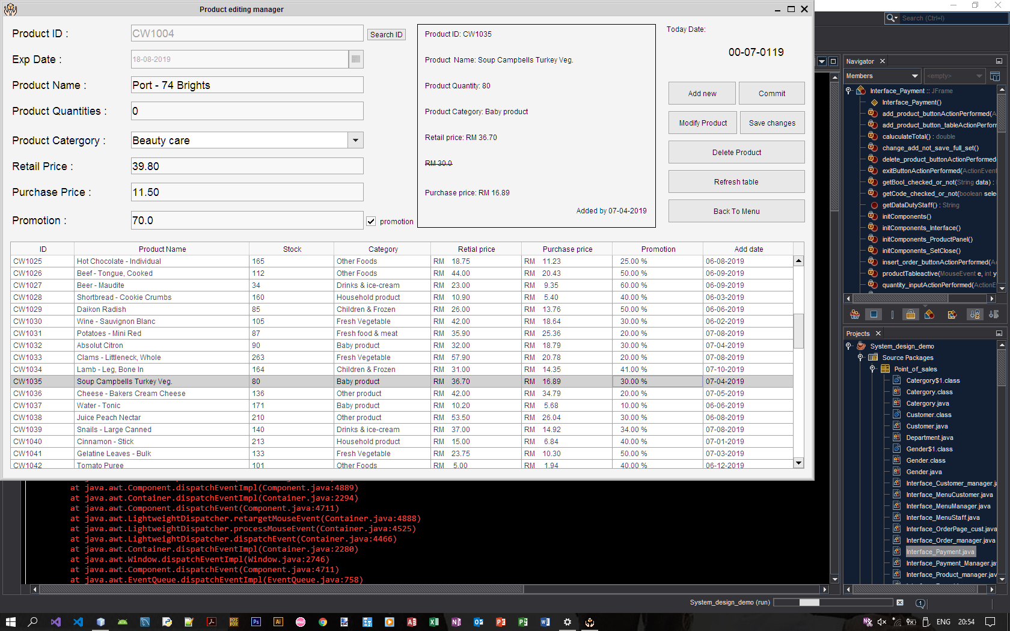

* + 1. Add new products

4.6.1.1 Click add new before commit

* + 1. Modify products

4.6.2.1 Modify product before save changes

* + 1. Delete products

#### 4.7 View Report Analysis

* 1. View report analysis

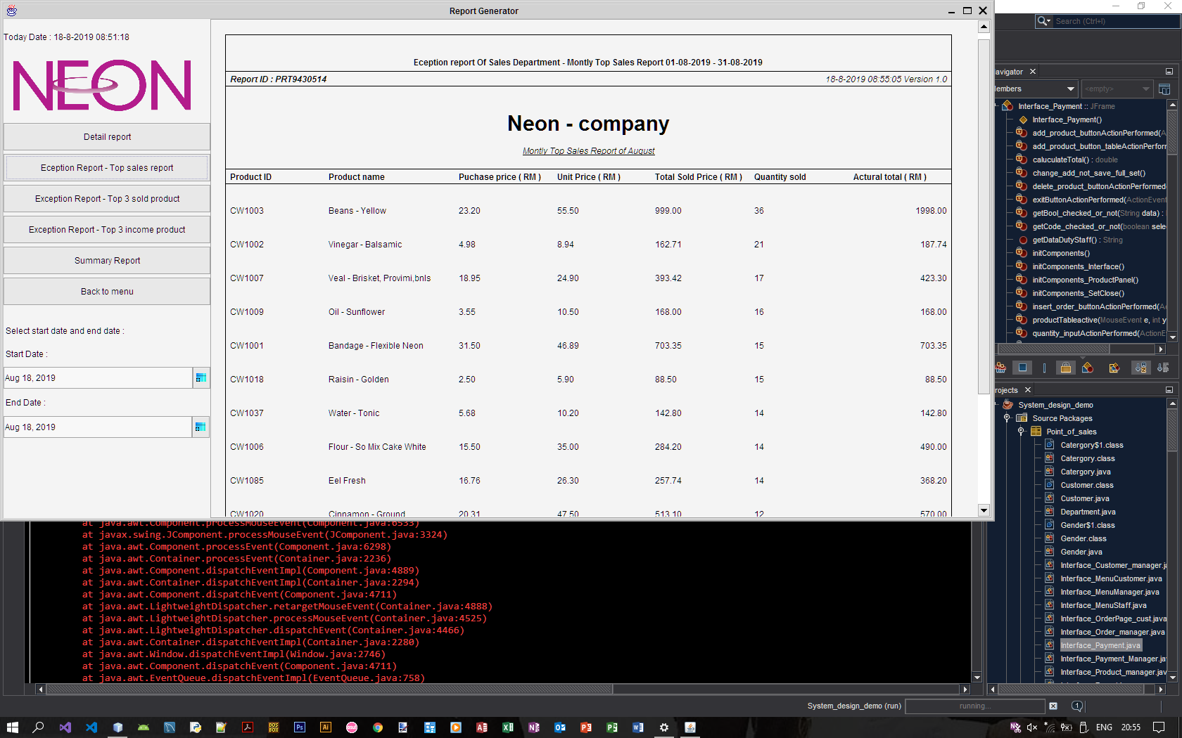

* + 1. Generate report interface three type of report will be generate at here one is detail report that is for first management to refer the diary track of the all order or payment in range of date by using the date combo has provided.
    2. Exception report Got three pages in this program. Once of them is list down the top sales of the particular month. Secondly is list down the top three sales product and provide a pie chart as a dashboard to refer. Thirdly is Top three higher outcome report that and provide the histogram to let user easy to compare their outcome.
    3. Lastly is summary report this report provide the bar chart of the higher sales to top management level to let them see the overall diagram and list down the problem product such as this month not sold out product, lower sales product, lower out come product, the net profit earn by the organization in the particular month, the total loss of money in this month and other.
    4. Start date and end date only provide too the detail report selection other report will be generate base on the current month.

#### 4.8 Insert structured query language command

* 1. Insert structured query language command

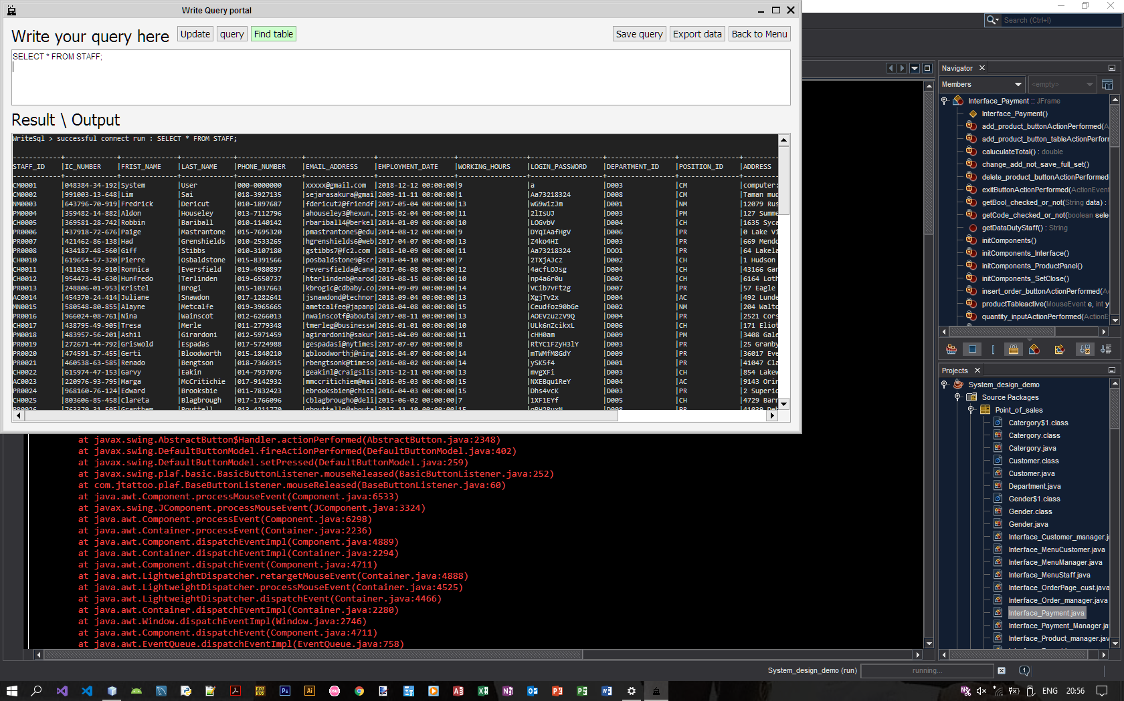

* + 1. Decision manager can straight away to use SQL code to insert or take out the data from the system.
    2. Manager they can decide either they want to update, find table only ensure they can find table and other performance.
    3. In this interface that have provide the saving query function to make the manager easy to find out the query when they need
    4. They can export the current data to the sql format to transferring data to database.
    5. One the user press the enter key the data will submit and result will be display out at the not editable text area labeled as Result/Output.

# **Appendixes**

## POS module



[Figure 1]

## Customer manager module



[Figure 2]

## Staff manager module



[Figure 3]

## Payment module



[Figure 4]

## Order module



[Figure 5]

## Product module



[Figure 6]

## Report module



[Figure 7]

## Online ordering module



[Figure 8]